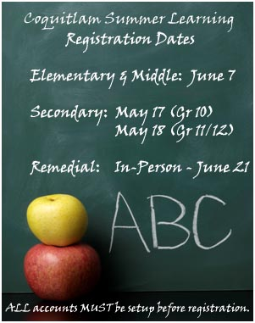
www.summerlearningcoquitlam.ca

